Types of Rhymes
# Source: AI Source: Provided by: [Data Path: Persons Table -> ID Column: 1, Name_En Column: Motasem Essam] -> From: [Chatgpt (GPT-4-turbo)] on [8/1/2025]
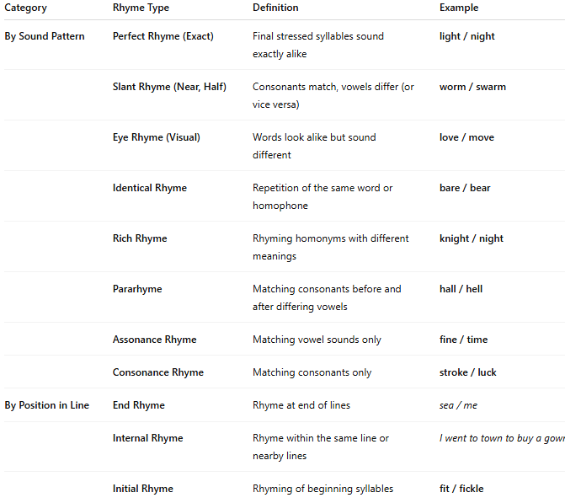
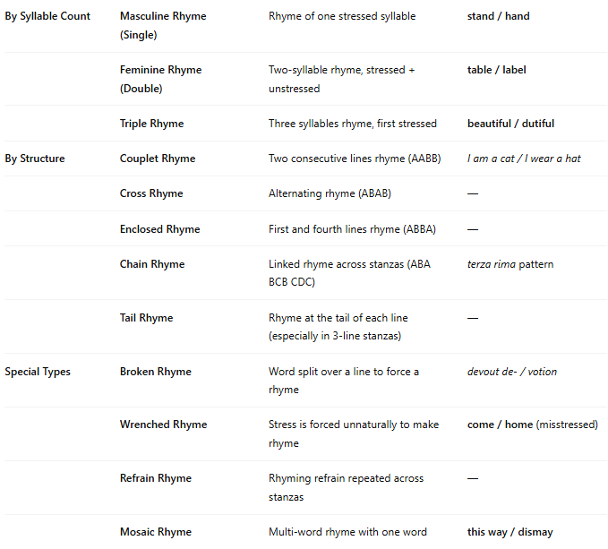

Category | Rhyme Type | Definition | Example
By Sound Pattern | Perfect Rhyme (Exact) | Final stressed syllables sound exactly alike | light / night
 | Slant Rhyme (Near, Half) | Consonants match, vowels differ (or vice versa) | worm / swarm
 | Eye Rhyme (Visual) | Words look alike but sound different | love / move
 | Identical Rhyme | Repetition of the same word or homophone | bare / bear
 | Rich Rhyme | Rhyming homonyms with different meanings | knight / night
 | Pararhyme | Matching consonants before and after differing vowels | hall / hell
 | Assonance Rhyme | Matching vowel sounds only | fine / time
 | Consonance Rhyme | Matching consonants only | stroke / luck
By Position in Line | End Rhyme | Rhyme at end of lines | sea / me
 | Internal Rhyme | Rhyme within the same line or nearby lines | I went to town to buy a gown.
 | Initial Rhyme | Rhyming of beginning syllables | fit / fickle
By Syllable Count | Masculine Rhyme (Single) | Rhyme of one stressed syllable | stand / hand
 | Feminine Rhyme (Double) | Two-syllable rhyme, stressed + unstressed | table / label
 | Triple Rhyme | Three syllables rhyme, first stressed | beautiful / dutiful
By Structure | Couplet Rhyme | Two consecutive lines rhyme (AABB) | I am a cat / I wear a hat
 | Cross Rhyme | Alternating rhyme (ABAB) | —
 | Enclosed Rhyme | First and fourth lines rhyme (ABBA) | —
 | Chain Rhyme | Linked rhyme across stanzas (ABA BCB CDC) | terza rima pattern
 | Tail Rhyme | Rhyme at the tail of each line (especially in 3-line stanzas) | —
Special Types | Broken Rhyme | Word split over a line to force a rhyme | devout de- / votion
 | Wrenched Rhyme | Stress is forced unnaturally to make rhyme | come / home (misstressed)
 | Refrain Rhyme | Rhyming refrain repeated across stanzas | —
 | Mosaic Rhyme | Multi-word rhyme with one word | this way / dismay

